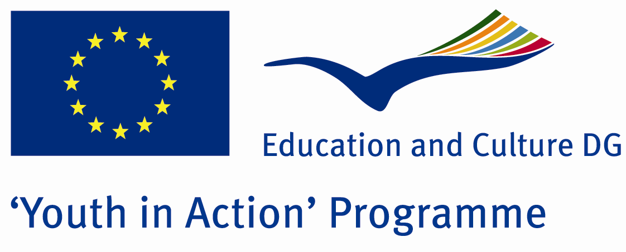

The Big Earthquake:17 August

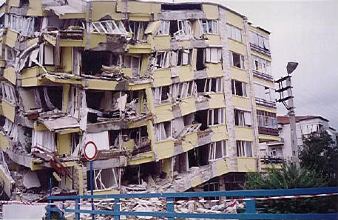

ACTION 4.3 – TRAINING AND NETWORKING

09-15th January, 2012

Kilis, TURKEY

ACTION 4.3 – TRAINING AND NETWORKING
09-15th January, 2012
Kilis, TURKEY

Please contact directly to;
adventurerpeacepigeons@gmail.com

Project Summary;

Earthquake is a natural disaster. What time, where they will be is not clear. Measure not taken a real serious consequences. Impossible to avoid, but not impossible to protect against earthquake. Earthquake as a country have paid a heavy price. After that we wrote this project to discuss what can we do?We are making preparation for a major earthquake. Do you contribute to us on this issue?

Project Title; The Big Earthquake:17 August

Date and Venue ; 09-15th January, 2012 Kilis, Turkey.

Target Group ; Municipalities, City Councils and Non-Governmental organizations,
youth groups,culture and art groups,e.t.c

Participants ; 5 people from each country (over 18 -25 ). Totally 8 countries.

Conditions ; Accommodation, board and programme costs will be financed through European Commission Youth in Action Programme (Action 1.1). Travel costs will be reimbursed in 70% (APEX Tarrifs). Organizations from all 27 EU member countries plus Liechtenstein , Norway and Iceland are eligible to take part.

Working language: English

Organizer; Discovery And Adventure Group

How to apply: If you are interested, please send your Part III forms to
by e-mail please (in word file). Scan Part3 format is enough for application.(Fulfilled Part III which you can find in the attachment, of course signed and stamped) ..

Next step 2;
Original send via regular post to this address please:
Ertan DERİN
Fevzi Çakmak Mahallesi Tuncer Sokak No:6 PENDİK/İSTANBUL/TÜRKİYE
e-mail : adventurerpeacepigeons@gmail.com
Mobile : 0090 542 393 93 90

If you have any questions you may contact with: adventurerpeacepigeons@gmail.com

Deadline: 15th May 2011

For Further information:
Contact Person
Ertan DERİN
Fevzi Çakmak Mahallesi Tuncer Sokak No:6 PENDİK/İSTANBUL/TÜRKİYE
e-mail : adventurerpeacepigeons@gmail.com
Mobile : 0090 542 393 93 90

